By Monika kumari
Amazon Best Selling Books Analysis 

Introduction
this is dataset download for Kaggle website. This project focus on analyzing Amazon best selling book using excel. Create dashboard find people favourite title , top author ,demanding category and stories, highest review title, top week list title and Best Sale rank book.

Data information
The dataset used in project contain Amazon Best selling Book records. In this included Rank, title, author name, category sub category, format, price in dollar ,rating ,week in list ,publisher, year published, unique code and BSR(best sale rank). Using this information analyize the data create dashboard and KPI cards.

Analysis
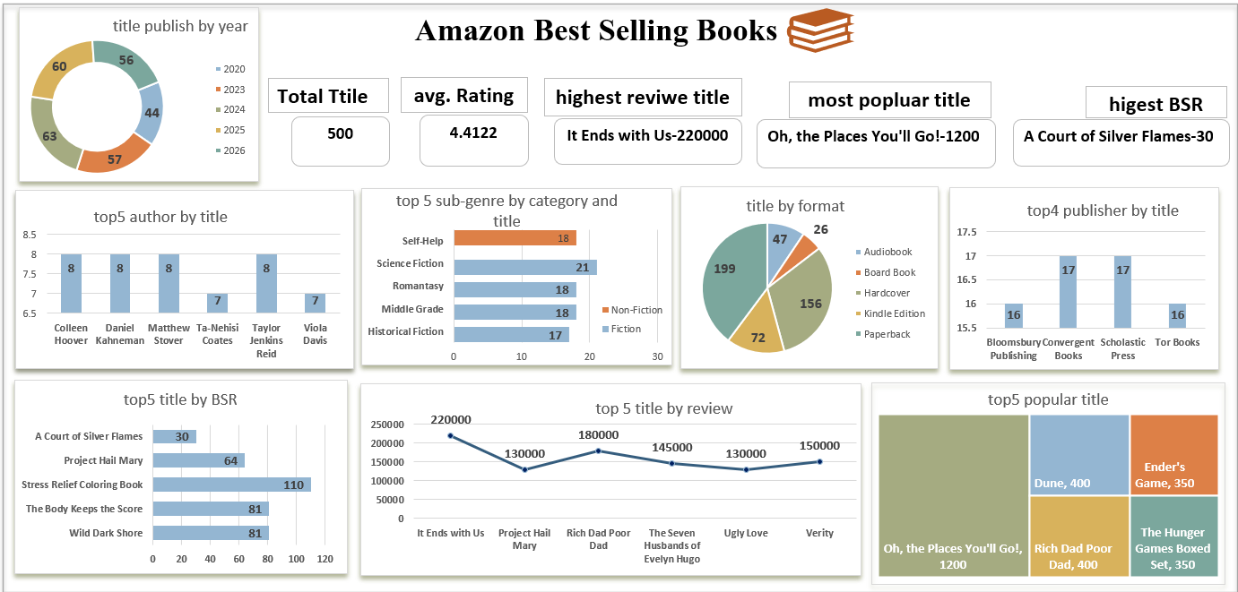

overview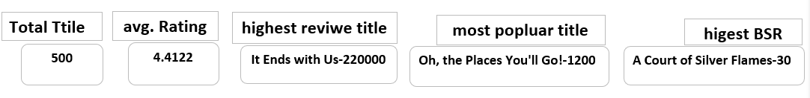
- total title is 500.
- average rating is 4.
- Reach highest review title is ‘it End with us’-220000 review.
- highest week in list title is “oh ,the place you’ll go!’’-12000 weeks
Highest Best selling rank title is “A Court of Silver Flames”-30 rank.

Title publish by year
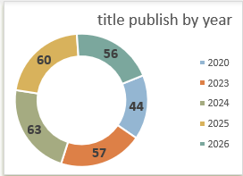
This is top 5 year publish 56% title in this year of overall data. But in 2024 is most publish title .

Top 5 authors
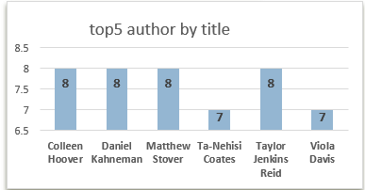
This is top 5 author of overall dataset. No any author write title above 8. Colleen hoover, Daniel Kahneman, Matthew stover and Taylor Jenkins Reid write same number of story .

Top 5 sub-genre by category and title
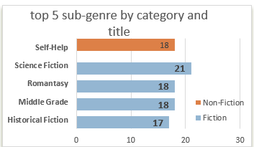
This is top 5 sub-genre by category fiction and Non fiction and title. Self-help type story write only non fiction category. But most demanding category is fiction type story.

Title by format
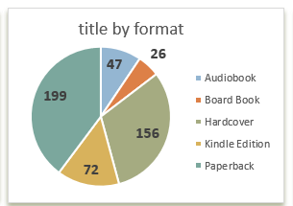
This is 5 type format book. Paperback format was the most preferred format .
Audiobook and board book has lowest number of title.

Top 4 publisher by title
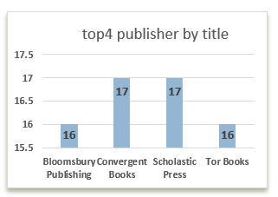
This is top 4 publisher name.

Top 5 title by BSR (best selling rank)
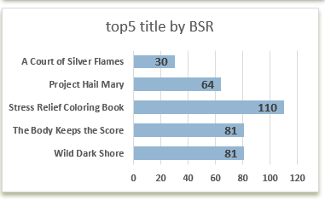

This is top 5 title name of best selling rank. A Court of silver Flames is one of the best selling rank of overall dataset .

Top 5 title by review
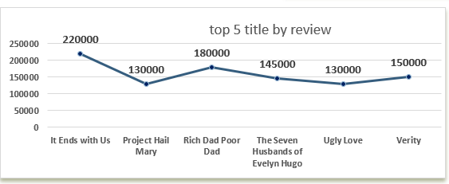
This is top 5 title name which reached highest review. It Ends with us is most highest review.

Top 5 popular title
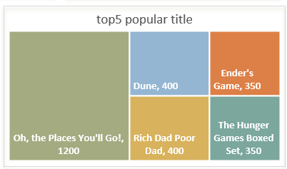
This is popular title name. oh, the Place you’ll Go! Is most popular title name but Rich Dad Poor Dad is same third position by review and title .
Conclusion
-Total title is 500.
-Average rating is 4
-Highest review title is “it End with us”
-highest week in list title is “oh ,the place you’ll go!
-Highest Best selling rank title is “A Court of Silver Flames”
- more title published in 2024 year.
-format most using paper back.
-self-help type story only fiction type

